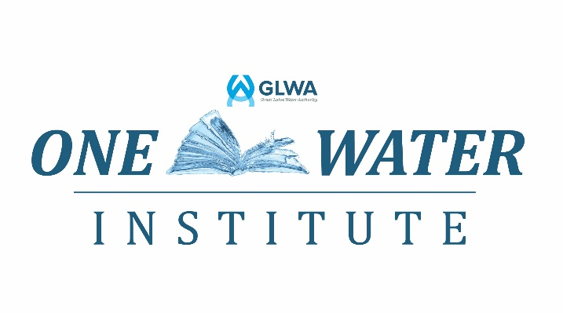

Common Courses that are offered each month include:

Health and Safety

General Health and Safety Awareness (Technical)
- Regulatory Standard(s): OSHA 29 CFR 1904, 1910.1200, 1910 Subpart I, 1910 Subpart D, 1910.146, 1910.147, 1910 Subpart O and 1910 Subpart E MIOSHA Part 11, Part 92, Part 33, Part 2, Part 90, Part 85, Part 7 and Part 6
- Hours: 8 hours

General Health and Safety Awareness (Administrative)
- Regulatory Standard(s): OSHA 29 CFR 1904, 1910.1200, 1910 Subpart I, 1910 Subpart D, 1910.146, 1910.147, 1910 Subpart O and 1910 Subpart E MIOSHA Part 11, Part 92, Part 33, Part 2, Part 90, Part 85, Part 7 and Part 6
- Hours: 4 hours

Toxic and Hazardous Substances Awareness
- Regulatory Standard(s): OSHA 29 CFR 1910 Subpart Z and MIOSHA Part 301
- Hours: 4 hours

Confined Space Entry Initial
- Regulatory Standard(s): General Industry: OSHA 29 CFR 1910.146 and MIOSHA Part 90 Construction: OSHA 29 CFR 1926.1200 Subpart AA and MIOSHA Part 35
- Hours: 16 hours

Confined Space Entry Refresher
- Regulatory Standard(s): General Industry: OSHA 29 CFR1910.146 and MIOSHA Part 90 Construction: OSHA 29 CFR 1926.1200 Subpart AA and MIOSHA Part 35
- Hours: 8 hours

Adult FIRST AID/CPR/AED
- Regulatory Standard(s): OSHA 29 CFR Subpart K and MIOSHA Part 472
- Hours: 4.5 hours

Bloodborne Pathogens
- Regulatory Standard(s): OSHA 29 CFR 1910.1030 and MIOSHA Part 554
- Hours: 1 Hour

Forklift (Hi-Lo)
- Regulatory Standard(s): OSHA 29 CFR 1910.178 and MIOSHA Part 21
- Hours: 4 hours

Hazardous Waste Operations and Emergency Response (HAZWOPER) 40-Hour
- Regulatory Standard(s): OSHA 29 CFR 1910.120 and MIOSHA Part 432
- Hours: 40 hours

Hazardous Waste Operations and Emergency Response (HAZWOPER) 8-Hour Refresher
- Regulatory Standard(s): OSHA 29 CFR 1910.120 and MIOSHA Part 432
- Hours: 8 hours

Lockout Tagout
- Regulatory Standard(s): OSHA 29 CFR 1910.147 and MIOSHA Part 85 MIOSHA Part 12 and Part 8
- Hours: 8 hours

Leadership Development

Crucial Conversations (Crucial Learning)
- Hours: 14 hours

7 Habits of Highly Effective People (Franklin Covey)
- Hours: 16 hours

