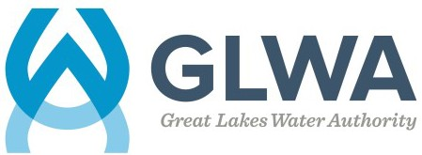

Instrumentation Control Technician
APPRENTICESHIP PROGRAM ANNOUNCEMENT

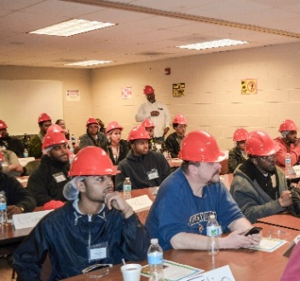
The Great Lakes Water Authority (GLWA), in collaboration with Focus: HOPE and Henry Ford Community College, announces the launch of a second three-year apprenticeship cohort to train and hire Electrical Instrumentation Control Technicians - Instrumentation (EICT-I) for GLWA. EICT-I technicians play an essential role in GLWA’s efforts to provide water of unquestionable quality to the residents of southeast Michigan, performing duties in plant operations, including the maintenance and repair of electrical and instrumentation equipment in the plants, field services, and pumping stations.
All interested candidates must successfully complete the Focus: HOPE pre-apprenticeship program to be eligible for the EICT-I Apprenticeship*. Upon completion of the Focus: HOPE pre-apprenticeship program, GLWA schedules interviews with qualified candidates for admission to the apprenticeship program.
Why Should I Enroll?

PAID JOB
Apprenticeships are jobs! Apprentices earn a competitive wage with anticipated salary adjustments every six months.

WORK-BASED LEARNING
Apprentices receive structured on-the-job learning from experienced technicians.

CLASSROOM LEARNING
Apprentices are provided classroom instruction through an educational partner at no cost to the apprentice

CREDENTIALS
Apprentices earn a portable, nationally recognized U.S. Department of Labor certificate.

MAKE A DIFFERENCE
Apprentices’ work is critical to the role GLWA plays in protecting public health through
the delivery of water of unquestionable quality!
How Do I Enroll?
- Contact Focus: HOPE at 313-494-4300 or admissions@focushope.edu to schedule the Comprehensive Adult Student Assessment Systems (CASAS) assessment. Candidates must also pass the assessment for enrollment in the Pre-Apprenticeship Plus (PA Plus) program (space is limited). The assessment is conducted in person and is free of charge. Candidates must complete the assessment by September 21, 2022, to register for the September 26, 2022, PA Plus class and to be considered for the 2023 EICT I Apprenticeship program. Candidates should allow up to three hours to complete the assessment.
- Apprenticeship Details: The pre-apprenticeship program is eight (8) weeks. The apprenticeship program is approximately three (3) years in length. The apprenticeship is scheduled to begin in January 2023.
- For more information: Attend a 30-minute virtual information session on Wednesday, Sept. 14th at 8 a.m. or 3:30 p.m. or Thursday, Sept. 15th at 8 a.m. or 3:30 p.m. Register by emailing performance@glwater.org with your name and requested session date and time. A Microsoft Teams invitation will be sent to you via email.
*If a candidate has completed a pre-apprenticeship program with another provider, the candidate should email GLWA at performance@glwater.org to determine if the Focus: HOPE pre-apprenticeship program will be waived.

